CSE422: Artificial intelligence
Assignment 01 + 02 [Fall 2025]

Name: |  | ID: |  | Section:

1. For the following graph, S is the starting node, and G is the goal node. Heuristic values are given in the table on the right.
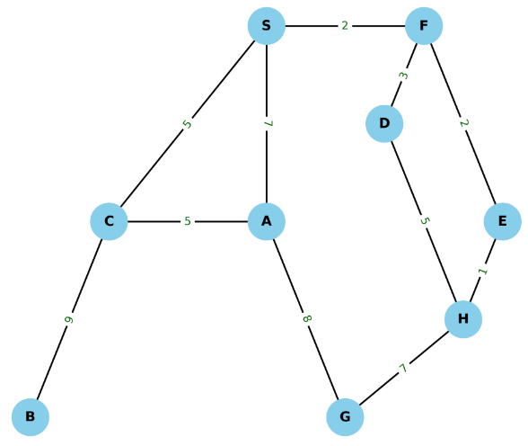

Node | Heuristic | Node | Heuristic
S | 12 | D | 8
A | 14 | E | 15
B | 16 | F | 9
C | 10 | H | 17

- Simulate Greedy Best-first search (GBFS) on the graph to find out the path to the goal, as well as the cost of the path.
- Simulate A-star search to find the optimal path to the goal, and compare it to GBFS output.

2. Imagine you have a 6×6 grid, where an agent’s goal is to move from the top-left corner (0, 0) to the bottom-right corner (5, 5). The movement costs are: horizontal or vertical = 1, diagonal = √2. You are given TWO heuristics:
- $h_{1}(n)=$Manhattan distance from node n to goal
- $h_{2}(n)=$Euclidean distance from node n to goal
Which of these heuristics will expand fewer nodes in this grid? Explain.

3. Design an admissible heuristic table for this graph. Consider A to be the source and E to be the goal.

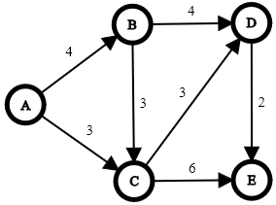

4. Suppose you are inside a grid-based maze, where each grid holds a treasure. The value of the treasure is given by an integer. When you are on a grid, you can collect the treasure of that grid, and you can also inspect the treasures in all neighbouring grids (i.e., the grids with which your current grid shares an edge or a corner). If you start from any of the corner grids (i.e. top-left, bottom-left, top-right, or bottom-right), can you find the highest valued treasure hidden in the maze using the hill-climbing algorithm? Explain why or why not. You can use the following grid given as an example.

1 | 4 | 3 | 2
6 | 10 | 5 | 1
2 | 9 | 8 | 4
3 | 1 | 8 | 15
5 | 7 | 3 | 6
4 | 6 | 5 | 10

5. Explain how the temperature parameter controls the probability of neighbour selection in simulated annealing.

6. Apply the Minimax algorithm with alpha-beta pruning on the following game tree to determine the best possible outcome for the MAX player at root node, assuming both MAX and MIN play optimally.
- Show alpha and beta values for each node.
- Show which branches can be pruned.

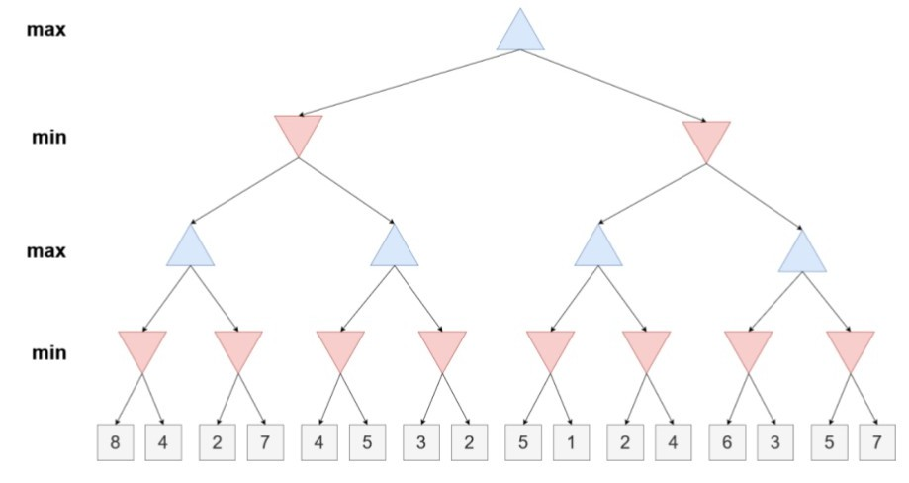
7. You are a delivery driver who must visit 8 cities exactly once and return to the starting point. Each pair of cities has a known distance between them, as given in the following table. Your goal is to find the shortest possible route that visits all cities once and returns to the start. You will use Genetic Algorithm to solve this problem.

 | A | B | C | D | E | F | G | H
A | - | 4 | 8 | 6 | 7 | 3 | 5 | 9
B | 4 | - | 2 | 7 | 3 | 6 | 8 | 5
C | 8 | 2 | - | 9 | 4 | 7 | 6 | 3
D | 6 | 7 | 9 | - | 2 | 4 | 5 | 7
E | 7 | 3 | 4 | 2 | - | 6 | 3 | 5
F | 3 | 6 | 7 | 4 | 6 | - | 2 | 8
G | 5 | 8 | 6 | 5 | 3 | 2 | - | 4
H | 9 | 5 | 3 | 7 | 5 | 8 | 4 | -

- Propose an encoding scheme to represent candidate solutions of the problem.
- Generate an initial population of 6 using the proposed encoding scheme.
- Propose a fitness function suitable for the problem.
- Run one iteration of Genetic Algorithm for this problem. Choose random crossover and mutation indices.
- Show the best solution after running one iteration.
- Show what the population for the next iteration will be using 2-elitism.

8. You are given a 4th order polynomial function: $f(x) = x^{4}-14x^{2}+24x+30.$ This function has many local maxima and minima, but our target is to find the global minimum value of the function. We will use Genetic algorithm for this.
- Propose an encoding scheme to represent candidate solutions of the problem. [Hint: your encoding must be such that it is possible to perform operations like cross-over and mutation. You could say x1 = 5, x2 = 6, … is a valid encoding scheme, but how would we perform cross-over or mutation? So, as you can see, it is not actually a good encoding.]
- Generate an initial population of 4 using the proposed encoding scheme.
- Propose a fitness function suitable for the problem.
- Run one iteration of Genetic Algorithm for this problem. Choose random crossover and mutation indices.
- Show the best solution after running one iteration.
- Show what the population for the next iteration will be using 2-elitism.

9. You are tasked with designing a seating arrangement for a wedding reception with 8 guests. The guests have specific preferences about whom they would like to sit next to and whom they want to avoid. You need to create a seating arrangement for these guests around a circular table. Depending on the guests' preferred seating arrangements, the aim is to optimize their level of satisfaction. Consider the following constraints:
- Guest 1 (G1) prefers to sit next to Guest 2 and Guest 3 but wants to avoid Guest 4.
- Guest 2 (G2) prefers to sit next to Guest 1 and Guest 4 but wants to avoid Guest 5.
- Guest 3 (G3) prefers to sit next to Guest 1 and Guest 6 but wants to avoid Guest 7.
- Guest 4 (G4) prefers to sit next to Guest 2 and Guest 5 but wants to avoid Guest 8.
- Guest 5 (G5) prefers to sit next to Guest 4 and Guest 6 but wants to avoid Guest 1.
- Guest 6 (G6) prefers to sit next to Guest 3 and Guest 5 but wants to avoid Guest 2.
- Guest 7 (G7) prefers to sit next to Guest 8 but wants to avoid Guest 3.
- Guest 8 (G8) prefers to sit next to Guest 7 but wants to avoid Guest 4.

You have to solve the problem using genetic algorithm.
- Encode the problem and create four parent chromosomes.
- Suggest a possible fitness function and choose the two fittest Chromosomes.
- Do you think the regular crossover (as in the n-queen problem) will work in this scenario? Explain why. [Hint: this is a permutation problem, just like the TSP one we saw in class. Each guest should only appear once in a permutation, but this constraint may be violated if we use regular crossover. We saw how to use an appropriate crossover for these cases in class.]
- Show how to perform mutation in this context.

10. State whether the following statements are TRUE or FALSE with an explanation. A short explanation is compulsory, just writing TRUE or FALSE will not yield any mark.

a. Simulated annealing's probability of denying worse solutions increases as the search progresses.
b. Simulated annealing guarantees better performance than hill climbing in all types of search spaces.
c. Simulated annealing becomes equivalent to hill climbing when the initial temperature is very high.
d. When optimizing a function with many local maxima of similar values, random restarts combined with hill climbing will never increase the likelihood of finding the global optimum.
e. A hill-climbing algorithm that stops after a fixed number of iterations will never find the global optimum if the number is large enough.

11. You are the surveillance officer of a museum. You want to bring the museum under CC-TV surveillance. You have THREE cameras, but you need to cover 20 distinct areas. Each camera has a CAPACITY, i.e. how many places (both towards its left and right) can a camera cover. For example, a camera with a CAPACITY of 3 can cover 3 places to its left, 3 places to its right, and the spot where it is placed (so altogether 7 places). The first two cameras have a CAPACITY of 2, and the remaining camera has a CAPACITY of 3. Based on this, you need to place the cameras at strategic positions so you can cover as many areas as possible. You will use genetic algorithm for this.
- Design an encoding scheme for the problem.
- Design a suitable fitness function.
- Using your encoding scheme, show FOUR parents and calculate their fitness.
- Will single point crossover work for this problem? Explain. [Hint: NO]

12. A company uses a machine learning algorithm to recruit its employees. However, there are some complaints that the algorithm has a bias based on certain demographic areas, gender, race etc, meaning that two candidates with similar qualities may not be given the same opportunity. To identify if any bias exists the company decides to divide a group of candidates into two subsets such that candidates with similar qualifications go to distinct subsets so they can find out if candidates with similar qualifications are getting different outcomes. The similarity score
between 6 candidates (A1... A6) is calculated based on skills, education, experience and is given below:
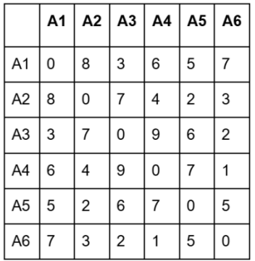
The task is to partition the candidates into two subsets such that the similarity scores between candidates in different subsets is maximized and the similarity score between candidates in the same subset is minimized. For example, if two candidates are in two different subsets the fitness should increase, if they are in the same subset then the fitness should decrease.
- Propose an encoding scheme to represent the solution in a genetic algorithm. Explain using an example.
- Define a fitness function to evaluate how good a partition is. Use the example from (a) to explain.
- Demonstrate the crossover operation between two randomly generated parents.

13. Problem Statement: Select food items to pack in the lunchbox so that the total volume does not exceed 1.5 liters and the total nutritional value is maximized.
Lunchbox Volume Limit: 1 liters
Food Items:
- Sandwich: Volume = 0.5 liters, Nutritional Value = 60
- Apple: Volume = 0.3 liters, Nutritional Value = 30
- Yogurt: Volume = 0.5 liters, Nutritional Value = 50
- Granola Bar: Volume = 0.2 liters, Nutritional Value = 40
- Carrot Sticks: Volume = 0.3 liters, Nutritional Value = 35

- Encode the problem, so it can be solved using any local search algorithm such as Hill Climbing.
[Hint: Encoding is similar to 0/1 knapsack genetic algorithm encoding, i.e. a string of binaries. However, in local search we need to have a START state. What will be the start state for this problem? When we choose no food item at all.]
- Explain how you would generate neighboring solutions for this local search method.
[Hint: For each state, a neighboring state can be found by adding one more food item. However, if we are at maximum volume limit, we can not find any neighboring states.]
- Using the given problem setup, demonstrate the main difference between Simulated Annealing and Hill Climb algorithm? Assume, Temperature parameter = 100 currently

14. Suppose you have three heuristic functions h1, h2 and h3. Among these h1 and h2 are admissible
but h3 is inadmissible. You have decided to create several new heuristic functions defined as
follows:
- h4(n) = 0
- h5(n) = 2 × h2(n)
- h6(n) = (h1(n)+h2(n))/2
- h7(n) = max(h1(n), h2(n))
- h8(n) = min(h1(n), h3(n))
- h9(n) = max(h2(n), h3(n))
Now answer the following questions and justify.
- Which two heuristics are possibly inadmissible?
- Among h6 and h7 which one is dominant?
- In your opinion which heuristic is the best?

15. Suppose you are to design an agent (circle) that knows how to play a game of tic tac toe against the user (cross). The following figure shows the current state of the game. Now the agent has to decide which move to make by using the minimax algorithm with alpha beta pruning.
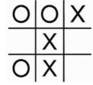
Determine which move would the agent prefer from the given state of the game. The final utilities will be [(100 - Depth) * 1] for a win, [(100 - Depth) * -1] for a loss and 0 for a draw. You must showcase the values of the nodes, α and β.
[Hint: Assuming the depth of the root node is 1, if a leaf node is found at the next level (depth 2) where the agent wins, then the utility for that leaf node from the agent’s perspective would be (100 - 2) *1 = 98. For a losing state it would have been (100 - 2) * -1 = -98]

----------------------------------

FORTUNE FAVORS THE BRAVE

